Project Description
In need of High-Speed UHF Tag Detection

Version 0.1 · 2019-07-05

Tag Type
NXP NTAG213 Ø 35 mm antenna size.

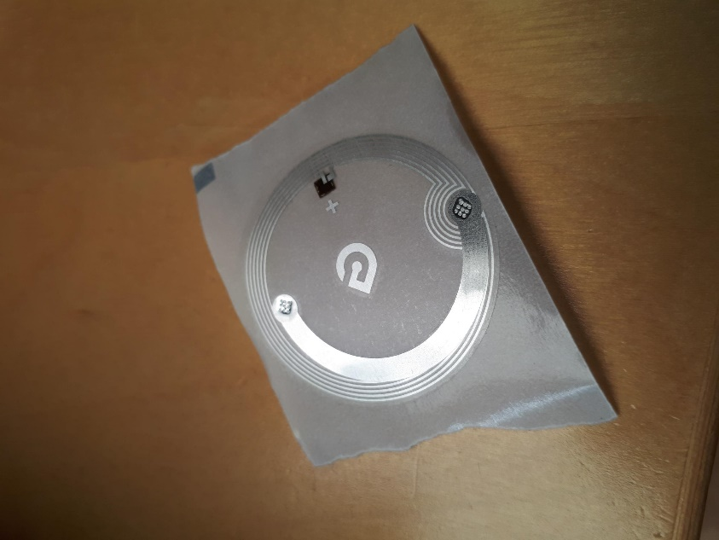

Problem
After update tag detection is worse than before. Pls. see this video:

http://chikek.idtronic.de/OEM-DES-R830-USB.mp4

First you see the older FW version, then a device with the newer FW version is used.

FW Information

Firmware Information before Update

Firmware Information after Update

