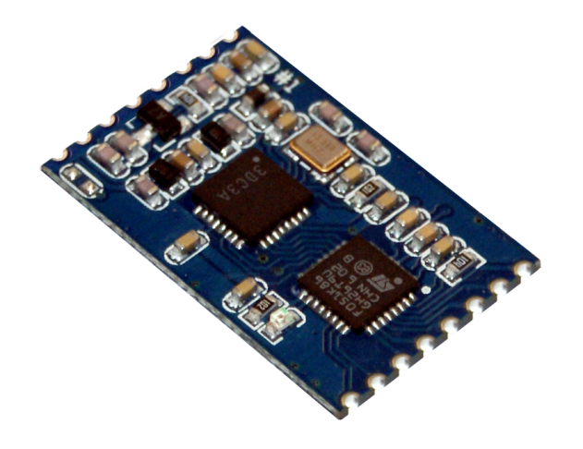

OEM-DES-RFID-Lock
13.56 MHz OEM RFID Lock with CAN interface
Development Description

iDTRONIC GmbH  Ludwig-Reichling-Straße 4  67059 Ludwigshafen  Germany/Deutschland  Phone: +49 621 6690094-0  Fax: +49 621 6690094-9  E-Mail: info@idtronic.de  Web: idtronic.de | Issue 0.1  – 09. October 2020 –  Subject to alteration without prior notice.  © Copyright iDTRONIC GmbH 2020  Printed in Germany
Contents
1 Project Overview 3
1.1 Firmware Update 4
1.2 Function Description Key-Operation (Standard Operation Mode) 4
1.3 Function Description Key Teach-In Operation 4
1.4 Configuration of the RFID-Lock 4
1.5 Needed CAN-Bus Commands 4
1.5.1 Initialising the RFID-Lock 4
1.5.2 RFID Key Handling 5
1.5.3 Service Commands 5
1.6 Glossary 5
2 Electric Requirements 5
2.1 Power Supply with Overvoltage Protection 5
2.2 Current Consumption 5
2.3 CAN-Bus with Overvoltage Protection 5
2.4 Connector 5
3 RFID Antenna 6
4 Mechanics 6
5 Environmental Conditions 6
6 Suggestion 6
7 Technical Data 6
8 Revision History 7

Project Overview
The complete device shall act as an RFID lock for a vehicle.

The RFID lock will be a DESFire keyfob. AES Encryption shall be used with the data stored onto the DESFire RFID tag.

Access information must be stored in a Trusted Flash Memory (e.g. TrustZone with ST MCUs). This information is:
- PICC password (do we really need this?)
- application number
- application password
- file number
- file password for read access
- file password for write access
- password for 3DES CAN-Bus encrypted communication

Communication with the vehicle is done using a custom-specific CAN implementation.
Communication with the vehicle is done using a 3DES encryption.

Firmware Update
It must be possible to update all firmwares (MCU + RFID) over the CAN-Bus.

Function Description Key-Operation (Standard Operation Mode)
- The RFID module detects the RFID keyfob.
- The RFID module wakes up the MCU.
- The MCU will switch the RFID module to standard operation.
- The MCU will send commands to the RFID module to read the key number (4 Bytes) using the previously stored access data from DESFire RFID tag.
- If a key number can be successfully read from the DESFire RFID tag, the MCU will send this number to the vehicle computer.
- The MCU will switch the RFID module to low-power card detection mode.
- The MCU will switch itself to low-power mode.

Function Description Key Teach-In Operation
The vehicle computer sends a CAN-Bus telegram to the RFID-Lock with the key number (4 Bytes).

The MCU will store the key number onto the DESFire RFID tag:
- PICCActivate
- RATS
- Create Application
- Select Application
- Set Application Access Password
- Set File Read Password
- Set File Write Password
- Create File
- Write key number (8 Bytes) into the file

After this, the RFID-Lock shall test if the data is correctly written onto the DESFire RFID tag. If the data is correct, the RFID-Lock will confirm to the vehicle computer.

Configuration of the RFID-Lock
Before the RFID device can operate as Lock all access information must be configured by the vehicle computer (or other IT equipment).

Needed CAN-Bus Commands

Initialising the RFID-Lock
- SetPICCPW (do we really need this?)
- SetAppAccessInfo (Flags, AppNr, KeyNr, Key)
- SetFileAccessInfo (Flags, FileNr, KeyNr, Key)
- Set3DESKey

RFID Key Handling
- TeachInKey (write 4 Bytes into file using initialized information)
- SendKeyNr (automatically by the RFID-Lock)

Service Commands
- TransferFirmware2RFIDModule
- TransferFirmware2MCU
- GetVersionInformation

Glossary
MCU = MicroController Unit
RFID = Radio Frequency Identification
App = Folder on DESFire RFID tag

Electric Requirements

Power Supply with Overvoltage Protection
Requirement
The supply voltage for the reader is between 7.6 V and 13.8 V.

The supply circuitry shall be able to withstand +60 Vdc and reverse polarity.
In overvoltage situation, there is no need to keep the normal function intact.
The power circuitry in the RFID Lock can switch off in case of overvoltage or reverse polarity.

Current Consumption
Requirement
Sleep: During sleep mode the current consumption has to be « 1 mA.
Active: During active mode the current consumption can be up to 120 mA.

RFID Module: < 50 mA
STM32L: 62 µA/MHz
Low-Power Mode
RFID Module: unknown
STM32L: 3 µA

CAN-Bus with Overvoltage Protection
The CAN-Bus shall be protected to withstand +60 Vdc.
In overvoltage situation, there is no need to keep the normal function intact.

Connector
JWPF from JST (pls. see data sheets from manufacturer)

RFID Antenna
Internal, depending on mounting position. TBD
External, with IP65 proof connector (e.g. SMA).

The antenna will be tuned for the low-power card detection mode + keyfob form factor.

Mechanics
The maximum dimensions shall not exceed 100 × 90 ×30 mm.

Environmental Conditions
Operating temperature range: -10°C to +50°C
Storage temperature range: -20°C to +60°C

IP64 or more. (potted electronics)

Suggestion
CHK305 with NXPs low-power card detection mode. Additional command to start this mode and configure it (if needed/possible).

STM32L5 as MCU with project-specific software and CAN interface.

Additional CAN-Bus interface LTC2875

Power supply circuit with overvoltage shut-off (sourced from other supplier).

Technical Data
Electrical Specifications
Power Supply | 7.6 … 13.8 V
Power Consumption | < 120 mA, standby current < 1 mA (low power mode)
Operating Frequency | 13.56 MHz
Baudrate CAN-Bus | 125 kbit/s, 250 kbit/s, 500 kbit/s, 1 Mbit/s
Antenna | TBD
Reader IC | CL 663
RF TX Speed | up to 848 kBd
Interfaces | CAN-Bus with custom-specific communication protocol

Environmental Conditions
Operating Temperature | -10 °C … +50 °C
Storage Temperature | -10 °C … +60 °C
Protection Class | IP64 or more
Humidity | up to 95 %, non condensing
MTBF | 200‘000 h

Applicable Standards
EMC | EN 301489-1:2012-04 (v1.9.21)  EN 301489-3:2013-12 (V1.6.1)
Radio Regulation | EN 300330-1:2015-08 (V1.8.1)  EN 300330-2:2015-08 (V1.6.1)
Safety | EC Guideline 2011/65/EU and amendment 2015/863  EN 50581:2012 (valid till 2024-07-07)  EN 63000:2018
RoHS 2 | EC Guideline 2011/65/EU
REACH | EU Guideline 1907/2006, updated by 2018/2005/EU
Certificates | FCC, CE

Other functions and details to be continued and upgraded.

Revision History
Date | Version | Description
2020-10-09 | 0.1 | Initial Draft

