 | Document  Technical Specification | version: v1.00  status:  date: 2013-05-06
project title: Protocol Analyzer – User Manual |  | doc

PROTOCOL ANALYZER

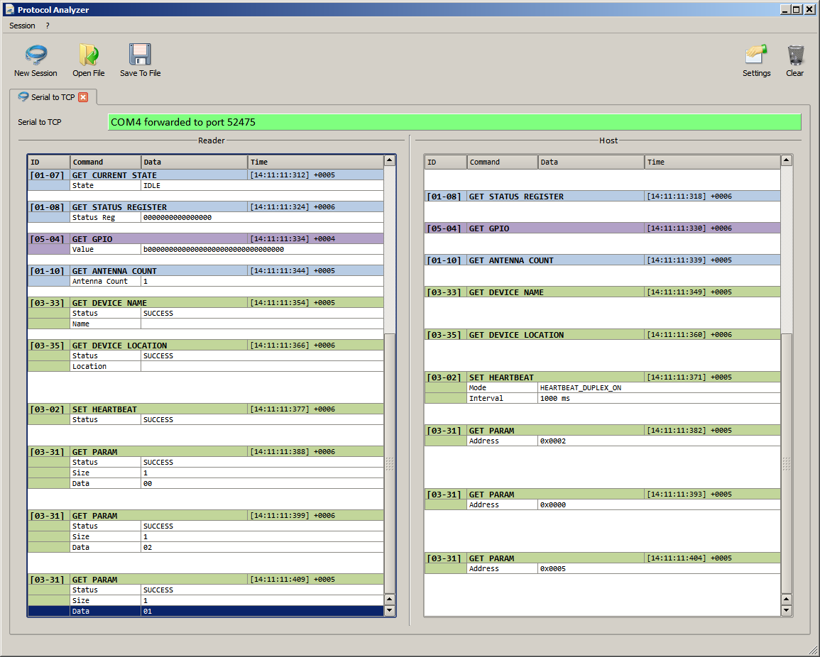

USER MANUAL

20130503_EN_UM - Protocol Analyzer
- User Manual_v1.00.docx
created by: Stefan Detter page: 1 von 4

 | Document  Technical Specification | version: v1.00  status:  date: 2013-05-06
project title: Protocol Analyzer – User Manual |  | doc

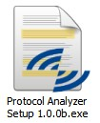1 Installing the Protocol Analyzer

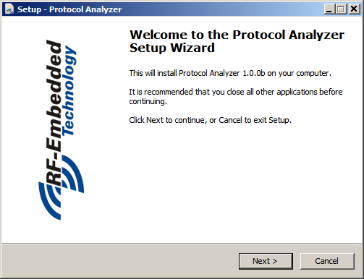To install the Protocol Analyzer execute the “Protocol Analyzer Setup”.

Step through the installation and select the options you like.

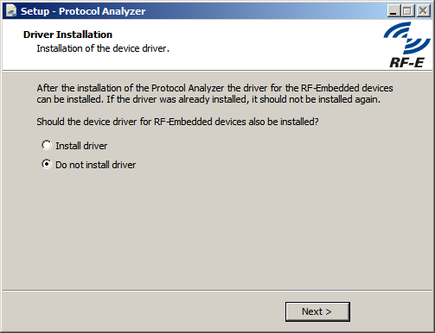On the last page after the installation you will be asked, if you want to install the driver for the RF- Embedded devices. If you are installing the Protocol Analyzer the first time, you should do so. If you already installed the Protocol Analyzer including the driver before, there is no need to install the driver.

20130503_EN_UM - Protocol Analyzer
- User Manual_v1.00.docx
created by: Stefan Detter page: 2 von 4

 | Document  Technical Specification | version: v1.00  status:  date: 2013-05-06
project title: Protocol Analyzer – User Manual |  | doc

2 Working with the Protocol Analyzer
The Protocol Analyzer is a tool that analyzes the messages that are sent to the reader by the host and vice versa. To analyze the messages the Protocol Analyzer is built up as a “man-in-the-middle” tool.

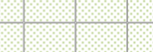Reader Host

TCP
Protocol Analyzer TCP

Serial
Serial
Not yet implemented

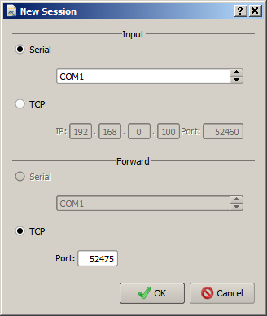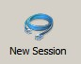To start a new analyzing session, just click the button “New Session”.

This brings up a dialog,
where you can choose the desired interfaces. The Input interface is the interface for the reader. The Forward interface is the interface for the host.
CAUTION: In the TCP forward mode the reader interface is not opened immediately, but when the host tries to connect to the reader. If there is any issue with opening the reader interface, the Protocol Analyzer will first show a message, when it tries to open the interface.

If the creation of a new session was successful, a new tab is shown. On top of the page, the interface settings are shown and coded by color the status of the connection:
• gray = idle
• green = connected

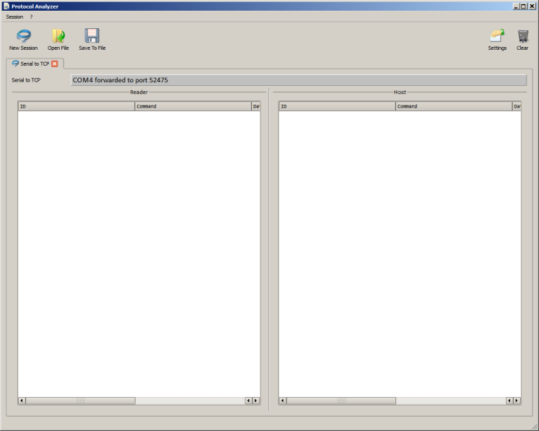20130503_EN_UM - Protocol Analyzer
- User Manual_v1.00.docx
created by: Stefan Detter page: 3 von 4

 | Document  Technical Specification | version: v1.00  status:  date: 2013-05-06
project title: Protocol Analyzer – User Manual |  | doc

When the first messages between the reader and the host are exchanged, the Protocol Analyzer shows these messages in the split screen.

The messages are color coded by the first command byte. If there is any problem parsing the data from either the reader or the host, the corrupt message is also shown in the table.

Each session got its own settings, which can be changed by clicking the button Settings. This brings up the following dialog.

The message table in the settings dialog offers the possibility to select or filter specific messages. When the messages are activated, they are shown in the stream.
The Add Raw Message checkbox offers the possibility to also show the raw messages that are parsed by the Protocol Analyzer.

CAUTION: All changes in this dialog only affect the messages that will be parsed in the future. The already parsed and shown messages stay the same.

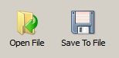With the buttons “Save to File” and “Open File” each session can be
stored into a file and again be opened. This makes it easy to debug remote applications.

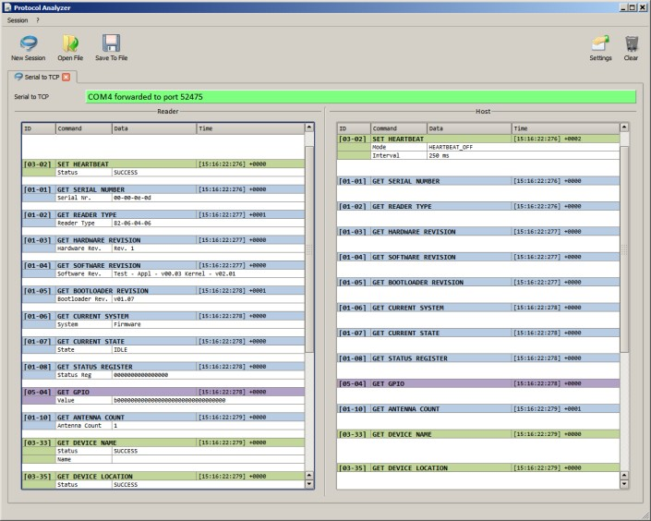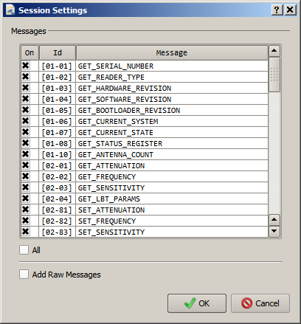20130503_EN_UM - Protocol Analyzer
- User Manual_v1.00.docx
created by: Stefan Detter page: 4 von 4

